ANALYSE OF REDDIT 2016-01-14

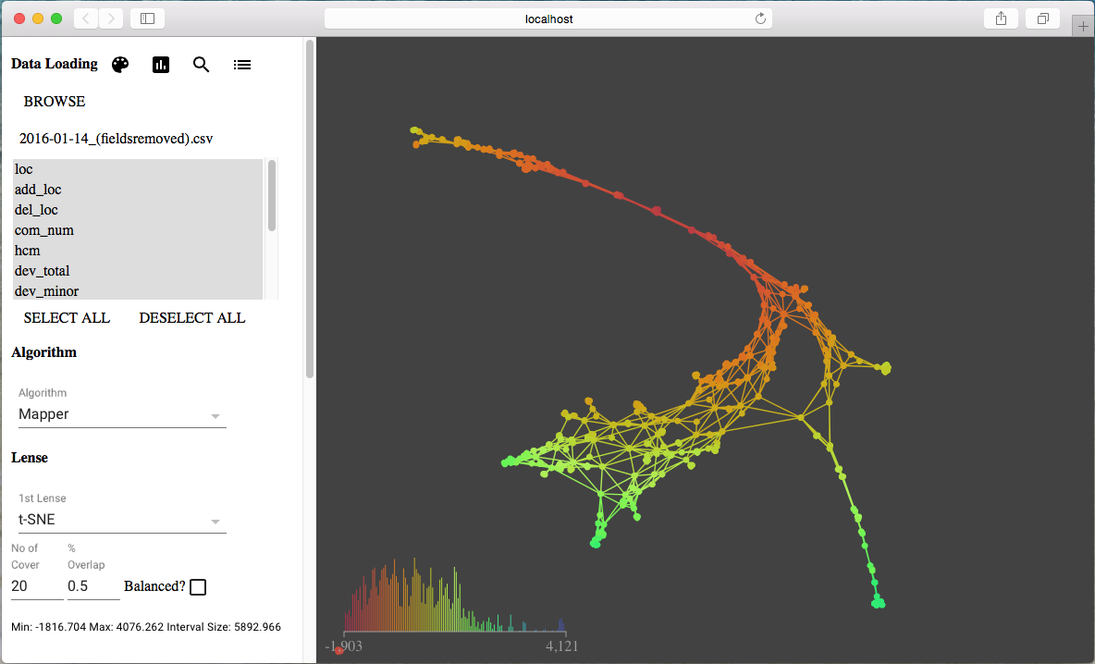

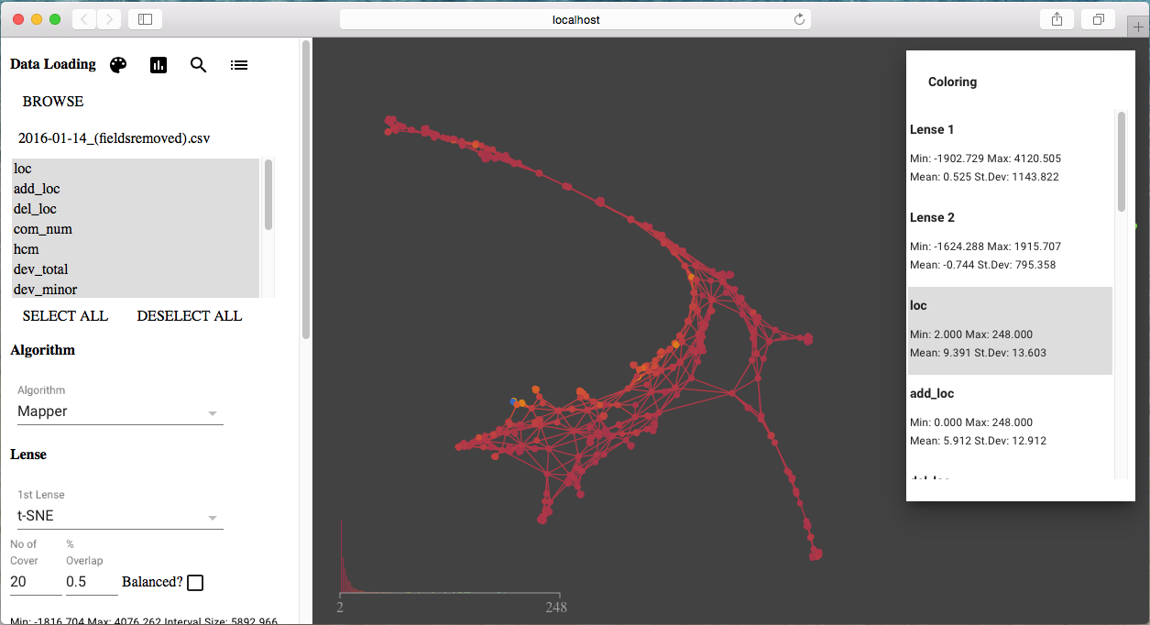

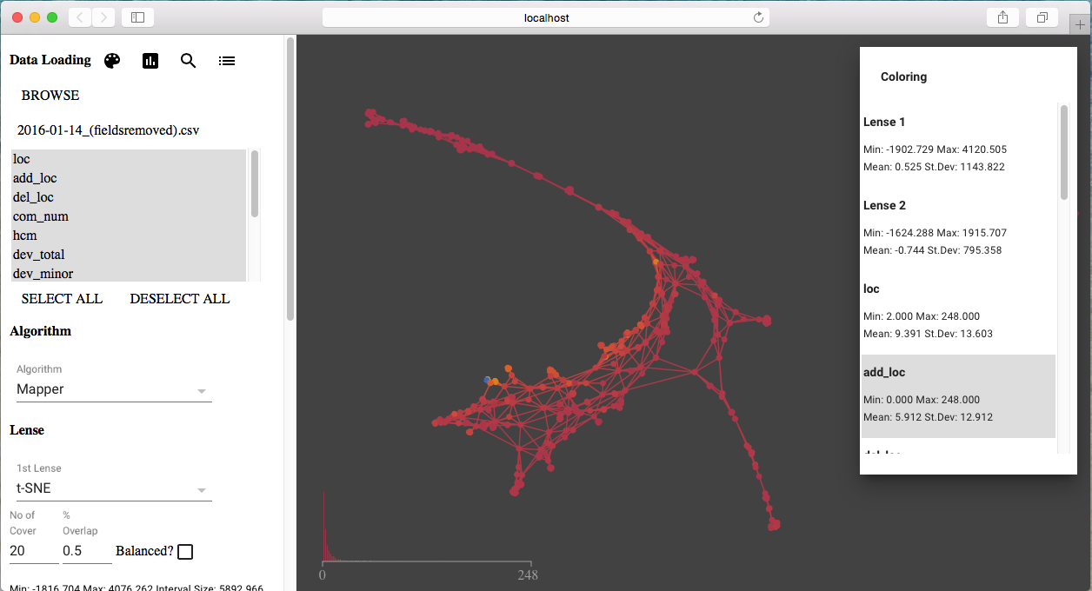

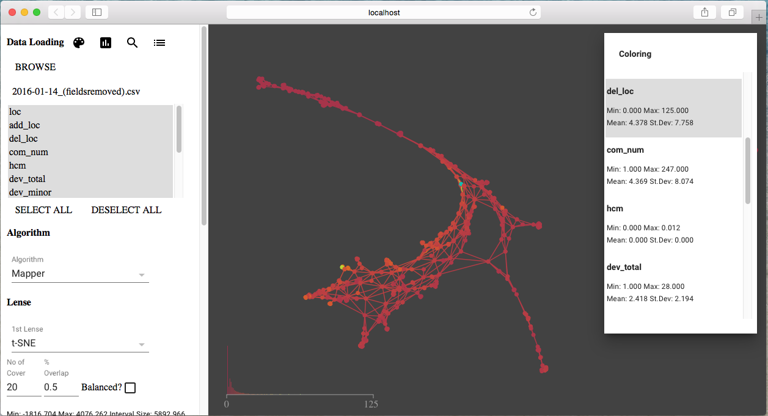

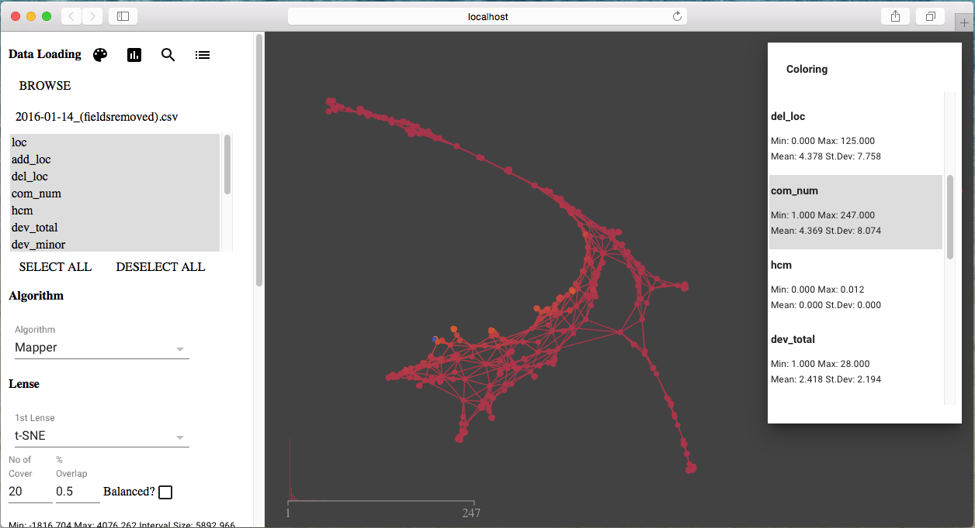

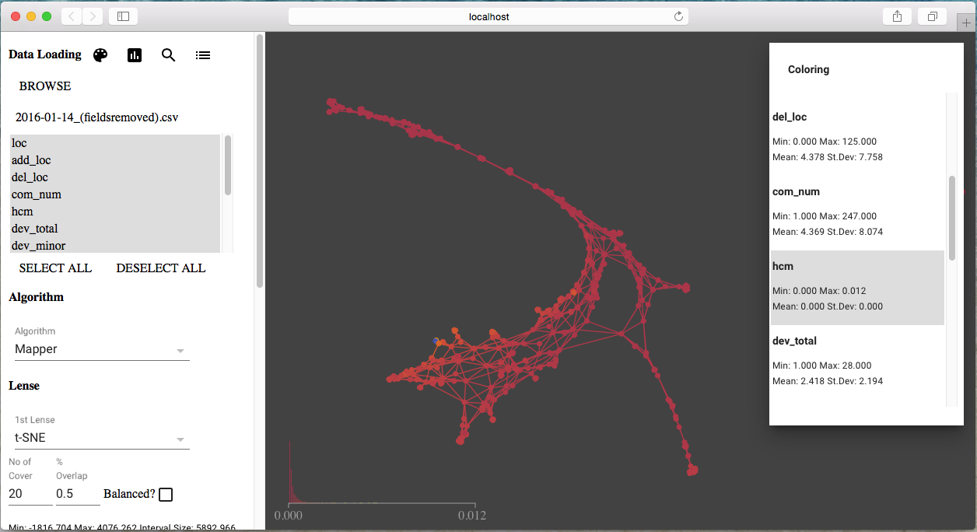

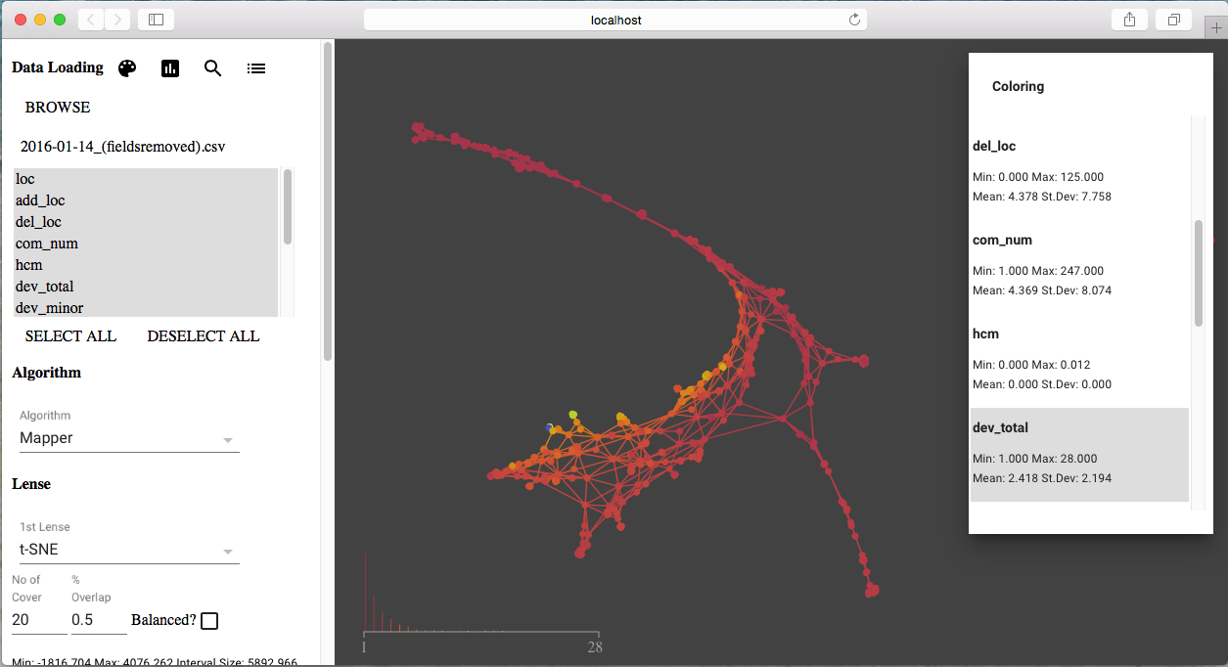

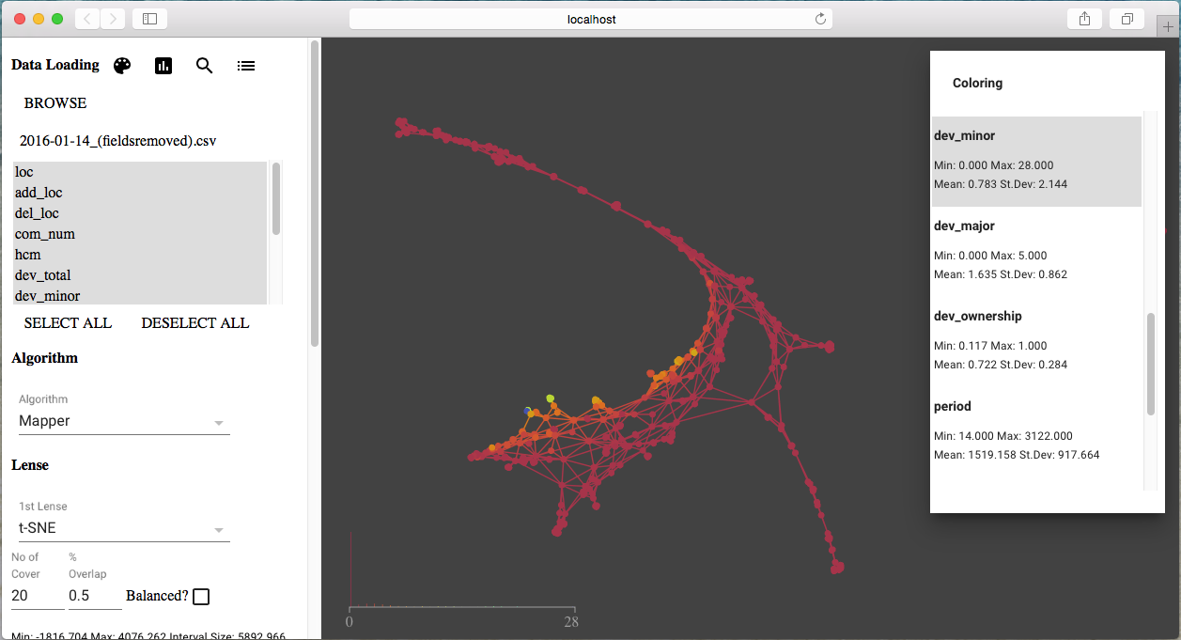

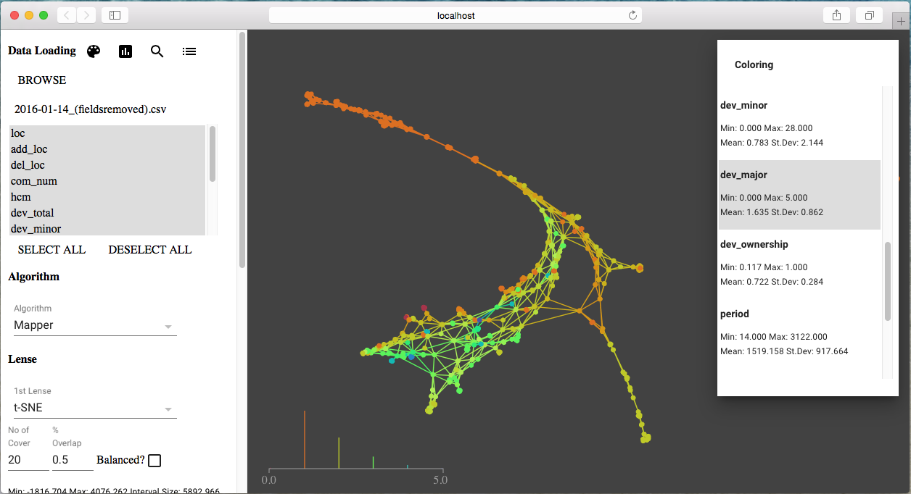

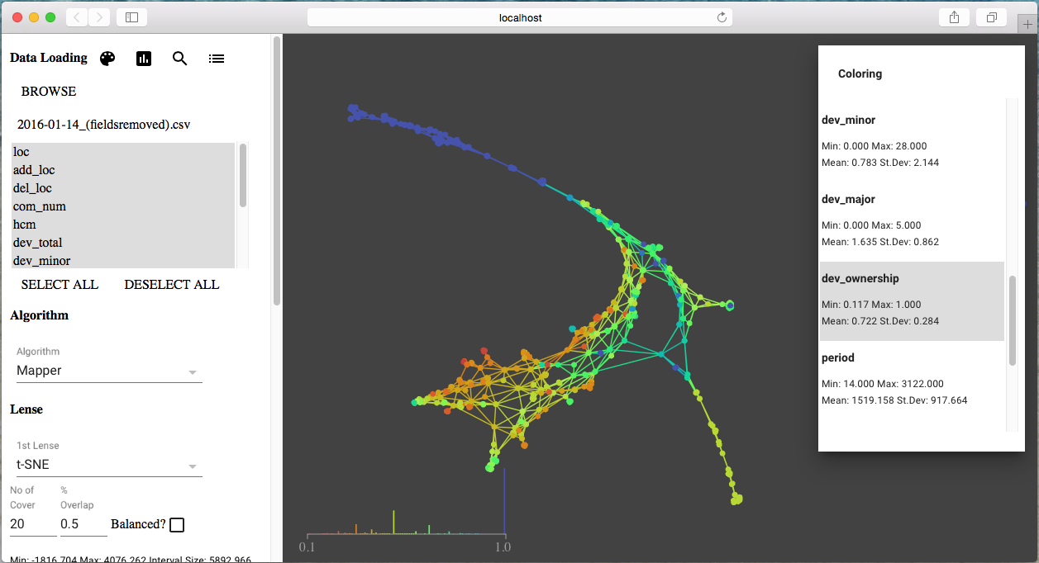

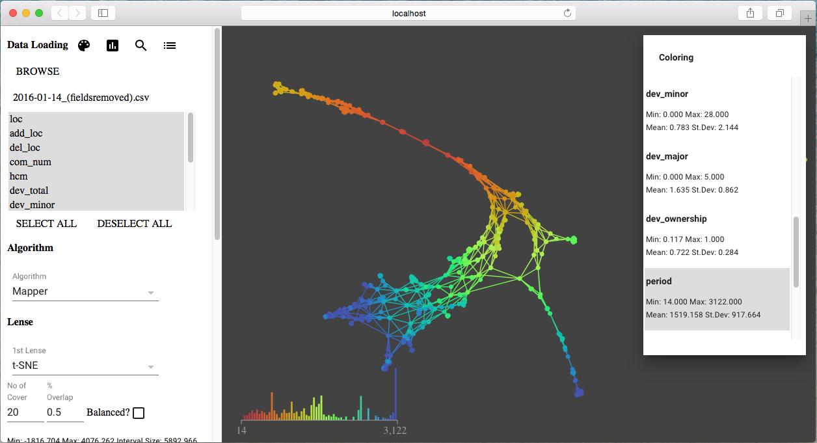

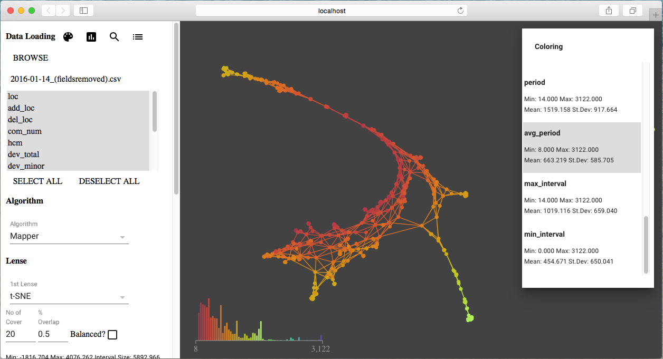

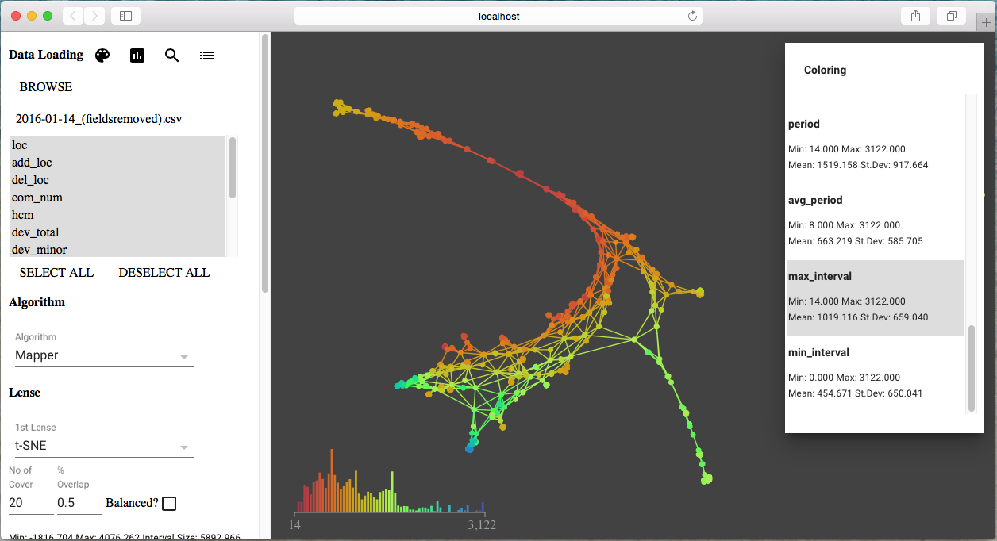

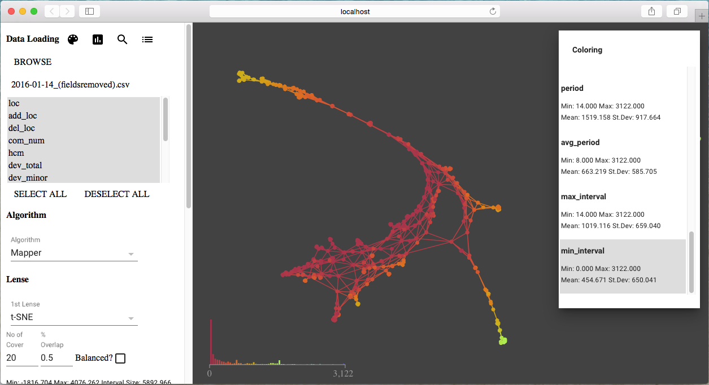

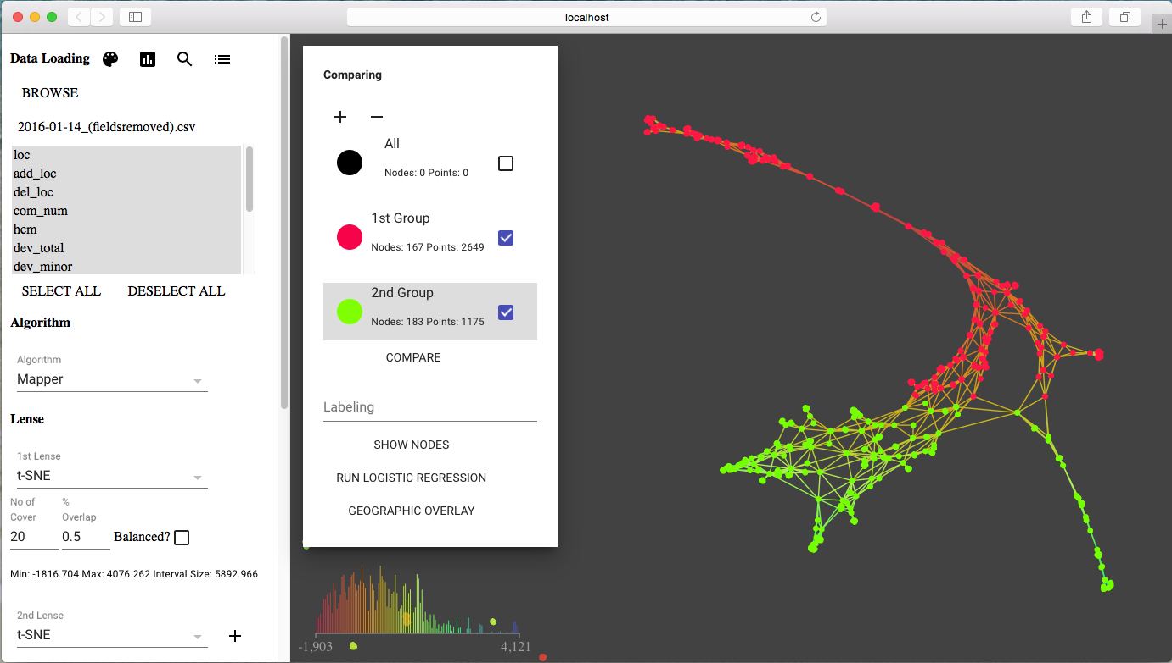

#### Analysis Result

|  |  |  |  |  |  |  |  |  |
| --- | --- | --- | --- | --- | --- | --- | --- | --- |
| **Variables** | **Group 1 min** | **Group 2 min** | **Group 1 mean** | **Group 2 mean** | **Group 1 median** | **Group 2 median** | **Group 1 max** | **Group 2 max** |
| loc | 2.0 | 2.0 | 8.977 | 11.809 | 6.0 | 6.0 | 106.0 | 248.0 |
| add_loc | 0.0 | 0.0 | 5.115 | 10.786 | 2.0 | 5.0 | 75.0 | 248.0 |
| del_loc | 0.0 | 0.0 | 4.105 | 7.232 | 2.0 | 4.0 | 99.0 | 71.0 |
| com_num | 1.0 | 2.0 | 3.266 | 8.551 | 2.0 | 5.0 | 74.0 | 247.0 |
| hcm | 0.0 | 0.0 | 0.0 | 0.001 | 0.0 | 0.001 | 0.002 | 0.012 |
| dev_total | 1.0 | 1.0 | 1.983 | 4.153 | 1.0 | 3.0 | 16.0 | 28.0 |
| dev_minor | 0.0 | 0.0 | 0.404 | 2.049 | 0.0 | 0.0 | 15.0 | 28.0 |
| dev_major | 0.0 | 0.0 | 1.58 | 2.105 | 1.0 | 2.0 | 5.0 | 5.0 |
| dev_ownership | 0.167 | 0.117 | 0.764 | 0.487 | 1.0 | 0.429 | 1.0 | 1.0 |
| period | 14.0 | 1337.0 | 936.744 | 2582.09 | 902.0 | 2591.0 | 2270.0 | 3122.0 |
| avg_period | 8.0 | 12.0 | 421.546 | 525.868 | 347.0 | 471.0 | 1088.0 | 1561.0 |
| max_interval | 14.0 | 166.0 | 659.932 | 1310.094 | 602.0 | 1281.0 | 1827.0 | 2898.0 |
| min_interval | 0.0 | 0.0 | 263.295 | 106.557 | 124.0 | 16.0 | 1088.0 | 1546.0 |